MAKATON BEGINNERS WORKSHOP

Dates: Thursday 16th February 2017
Friday 17th February 2017
Participants must attend both days to receive their certificate

Time: 9.30am-4pm

Venue: Portadown Health Centre, Tavanagh Ave
(meeting at the SLT waiting area)

Course outline: This workshop is a practical introduction to Makaton. It covers all signs and symbols from stages 1-4 and the additional vocabulary.
Commonly asked questions will be discussed and hints and tips given for effective signing and symbol use in everyday situations at home or work.

Cost: £32 per person/family (see priority criteria)
Payable to Cherith Doonan on application
(Cost is for the manuals to accompany the workshop which include stages 1-4 and additional vocabulary signs and symbols and certificate.) N.B lunch is not provided
For further information contact:
Cherith Doonan, SLT, Makaton Regional Tutor
Tel: (028) 87713026
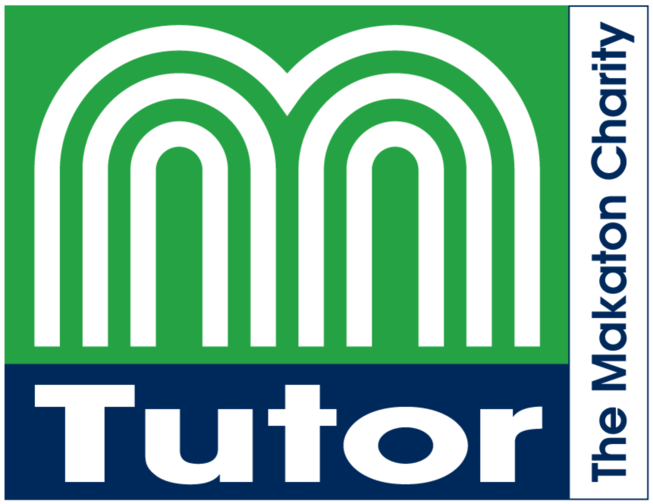cherith.doonan@southerntrust.hscni.net
Closing date: 27th January 2017
(Maximum Numbers- 15)
MAKATON BEGINNERS WORKSHOP

Priority Criteria and Cost

- Parents/carers of children known to SLT services in the Southern Trust who are Makaton users or potential users. Cost: £32

- SLT Staff including assistants Cost: £32

- Teachers/CRA’s/Other professionals with frequent direct contact with children on the SLT caseload in the Southern Trust who are Makaton users or potential users Cost: £32

- Southern Trust staff who have regular contact with children who are Makaton users or potential users
e.g. Paediatric Nursing staff, Sure Start Staff
Cost: £32

Cost is payable to Cherith Doonan at the time of application and will be refunded if spaces are not available.

The cost is for the manuals to accompany the workshop which include stages 1-4 and additional vocabulary signs and symbols.
The 15 places on the course will be allocated according to the above criteria.

A waiting list of applicants will be complied if
necessary and places allocated in further courses.

It is anticipated that courses will run annually.

