Benefits of Sensory Motor Activities

- Improvements in Motor Skills
  - Postural stability/balance/bilateral integration
  - Upper half Stability-shoulder strength
  - Hand Function-dexterity
  - Handwriting-called a new skill

- Improvements in Social/Emotional
  - Increase in confidence
  - Less Anxiety
  - Willingness to attempt new activities
  - Friends/social skills

- Improvement in behaviour and readiness to learn:-
Sensory regulation and Attention

Sensory Motor Activity Ideas for home:
Crawling on all 4s:
Through a tunnel, under a blanket, upstairs, under a table

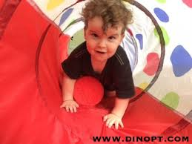

Commando crawling:
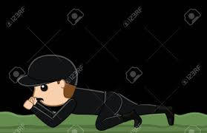

Jumping x 10:
On the spot (you can hold hands to control force of bounce) , forwards on to a target (ie patterns on a carpet or different tiles), in a puddle or a trampoline
Lying on tummy:
Over a footstool or small chair or exercise ball if you have it
Rolling
Whole body roll to knock down skittles or toilet rolls
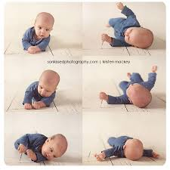
Row you boat:
Sit facing each other in a tailor/cross legged sitting position. Reach out and hold hands in front of your bodies and begin to alternately push and pull so that upper bodies rock forward and backward with each motion, like rowing a boat.

How to Change it Up:
-Sing Row, Row, Row Your Boat or another favorite song as you do each of the activities, rocking/rolling/swaying to the rhythm of the song to add to the calming effect.
-Experiment with moving fast and slow – have the child be the captain of the boat, telling you how to move!
-See if you can create more fun ways to ride the waves!
