**JA5 Home Learning**

8-12th February 2021

Theme: Valentine’s Day and Chinese New Year Colour: Pink Shape: Heart

******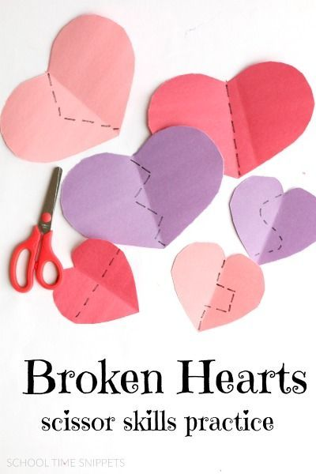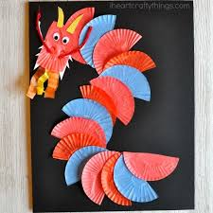**

**Valentine’s Day**

Five Little Hearts

<https://youtu.be/n5noNWgcAAE>

**Daily songs**

Good Morning

<https://youtu.be/CuI_p7a9VGs>

Brush Your Teeth

<https://youtu.be/wCio_xVlgQ0>

Shake Our Sillies Out

<https://youtu.be/NwT5oX_mqS0>

**Phase 1 Phonics**

Listening Activity

<https://youtu.be/Z2A6Ca_HZUQ>

**30 JAN 2019**

**Early skills**

Sorting

Pink items from a selection of coloured items

Money

Sort coins from a selection of items

“money v not money”

Cutting skills

Use safety scissors to cut hearts in half

**Chinese New Year**