APPLICATION FORM
MAKATON Beginners WORKSHOP

Thursday 16th February 2017
Friday 17th February 2017
9.30am-4pm
Portadown Health Centre, Tavanagh Ave
(meeting at the SLT waiting area)
Participants must attend both days to receive their certificate

Name:
Address:

Postcode:

Contact Number:
Email address:

Parent/Carer
Please give the name of the SLT seeing your child:
Professional
Please indicate your profession:

Cost: £32 per person/family (payable to Cherith Doonan) please enclose with application
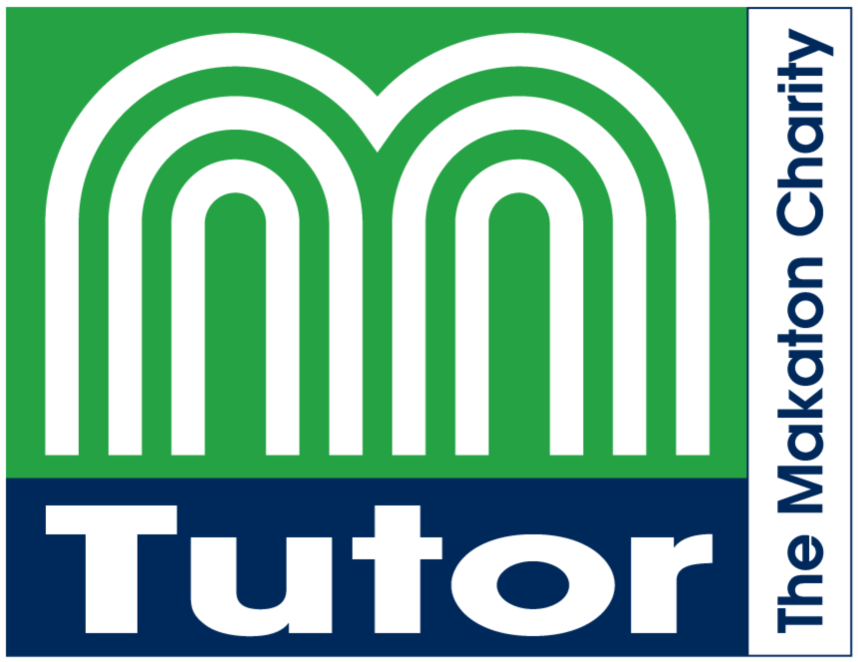Closing Date: 27th January 2017
Applications to: Cherith Doonan (SLT)
Dungannon Health Clinic,
Thomas St, Dungannon BT70 1HS
028 87713026

