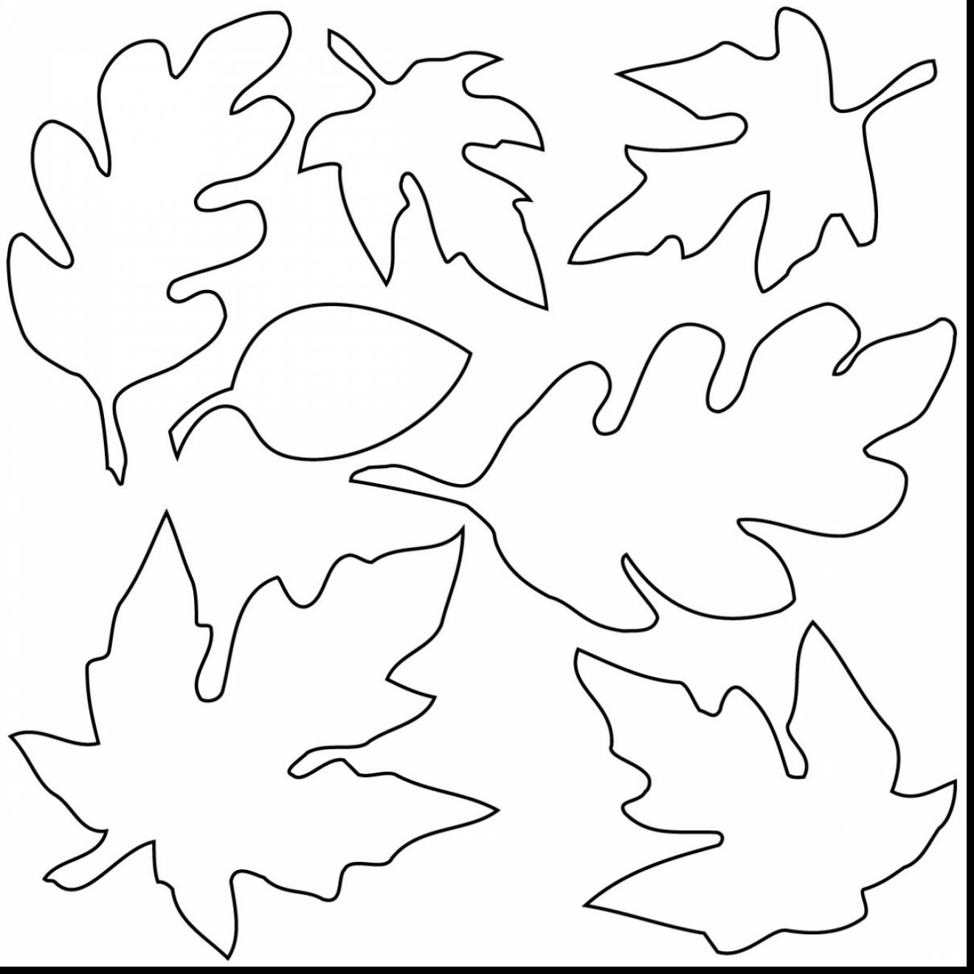

[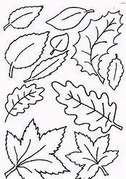](https://www.bing.com/images/search?view=detailV2&ccid=r97LTSaX&id=74D60C3B2BAEE11586784EC257D5DF2E179FA07C&thid=OIP.r97LTSaXKIcKCsQKOdNtjAHaKg&mediaurl=http://www.coloringpages1001.com/coloring-pages/leaf/leaf-coloring-pages-7.gif&exph=797&expw=562&q=leaves+for+colouring+in&simid=607994281182432374&selectedIndex=4&adlt=strict)

[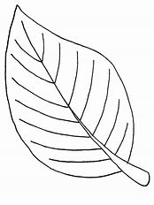](https://www.bing.com/images/search?view=detailV2&ccid=aQmh0UhS&id=9C894F4A6FD74548FEBDBD36E0D138B0B29D24BA&thid=OIP.aQmh0UhSdsWcsnJ_vmdTNQHaJ4&mediaurl=http://www.coloringville.com/images/leaf-coloring-pages/leaf-coloring-pages-3.png&exph=1136&expw=852&q=leaves+for+colouring+in&simid=608012500463256690&selectedIndex=0&adlt=strict)