**JA5 Home Learning**

15-18h February 2021

Theme: Pancakes! Colour: Pink Shape: Heart

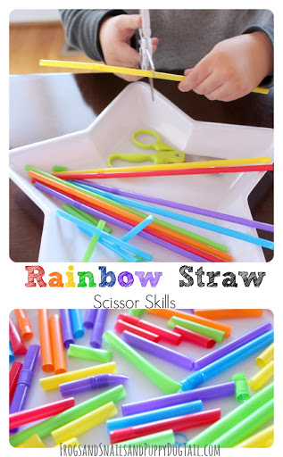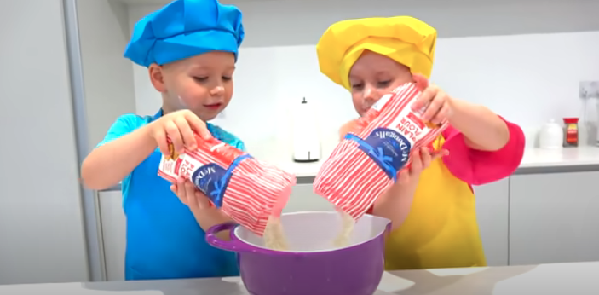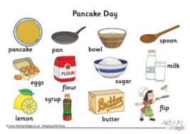

**Making Pancakes together offers so many opportunities for learning**

MATHS

Following a recipe – sequencing skills

Counting the spoonfuls

Measuring – using scales

MOTOR DEVELOPMENT

Mixing/stirring

Flipping pancakes

FUN

Counting the flips!

Laughing!!

**Language Development**

**Pancake Day**

Pancake making

<https://youtu.be/Tn4zks0bbTs>

**Daily songs**

Good Morning

<https://youtu.be/CuI_p7a9VGs>

Shape Song

<https://youtu.be/TJhfl5vdxp4>

Traditional Pancake Rhyme

<https://youtu.be/N41kZCfRkuk>

**Early skills**

Shape

After Valentine’s Day – can you make a

collection of hearts?

Money

Sort coins 1p, 2p, 5p, 10p

Cutting skills

Use safety scissors to snip straws