

Sperrinview Special School

Principal: Miss P Jordan Sperrinview Special School
8, Coalisland Road,
Tel: 028 8772 2467 Dungannon,
Co Tyrone.
Fax: 028 8772 3604 BT71 6FA

E-mail: mjordan389@c2kni.net
19/03/20
Dear Parent,

These are unprecedented and challenging times in which we live at the moment.

We wish to offer our support to you as we enter this new phase of school closures, so as you are aware, classroom staff have made up packs of physical materials and we will be placing online materials onto our website for you to access weekly. These may be accessed by:

- Typing in the school web address: www.sperrinviewspecialschool.co.uk
- Go to the Parent Area
- Choose Home Learning
- You will be asked to enter a password. I will send this in a text later today
- You will now be able to access a General folder which will contain useful information,
websites etc, as well as the folder for your child’s class.

Materials will be uploaded each Friday by 3pm for the week ahead.

In the Physical packs provided by classes, you will receive a class letter, containing the class teacher’s email. This will allow you to contact the teacher if you require support, however, I would ask that this is only used during school hours, 9am-3pm, Monday to Friday during term time. Teachers will check emails daily [when internet is accessible] and reply to you as soon as possible. Please remember that teachers may also have their own children at home during this time.

I want to wish you and your family good health and urge you to keep safe and healthy, being mindful of your own mental well-being throughout this time. Make many happy memories with your child, and don’t forget to take lots of photos, which you can email to teachers, so that we can share with you during this period of absence from school. Hoping to see you again soon.

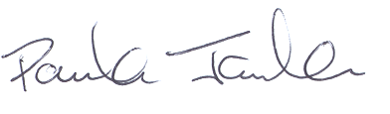Yours sincerely,

Paula Jordan Principal

